* Control of Body Temperature

# 273

**Key Idea:** Animals control body temperature by exchanging heat with their environment.

For a body to maintain a constant temperature heat losses must equal heat gains.Heat exchanges with the environment

occur via three mechanisms: **condu ction** (direct heat transfer), **radiation** (indirect heat transfer), and **evaporation.** The importance of each of these mechanismsdepends on environment, i.e. air or water.

Seals, whales and dolphins have heavily insulated surfaces of fat or blubber (up to 60%of body thickness). Blood is diverted to the outside of the blubber in warm

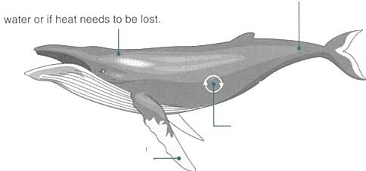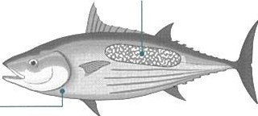

Large body size reduces heat loss by lowering the surface area to volume ratio.

Water has a great capacity to transfer heat away from organisms; its cooling power can be more than 50 times greater than that of air.For most aquatic animals (with the exception of aquatic birds and mammals and a few fish) heat retention is impossible.Instead, they carry out their metabolic activities at the ambient temperature. For most marine organisms this does not fluctuate much.

Heat loss from flippers and tail flukes is minimised by the use of count ercurren t heat exch angers in which heat is transferred between arterial

In all animals, metabolic activity generates heat.

In fasl swimming fish, such as Iuna, martin, and some sharks, heal exchangers are usedto mainlain lemperatures as high as 14"C above the water temperalure in lhe swimming muscles,

### Temperature regulation mechanisms in water

Low metabolic activity

* + H eat generation from metabolic activity

and venous blood flows.

In animals with gills, there is a high rate of heat loss across the thin gill surface.There is little point in surface insulation of the body, because all the arterial blood coming from the gills is already at water temperalure.

* + Insula t ion layer of blubber

Changes in circulation patterns when swimming

Large body size

Heat exchange systems in limbs or high activity muscle



-50

-70

20

0

·20

Air temperature

on land

50

Sea and**·i-** fr esh water ·-·

•c

100

70

**Envi ronmental**

**tempera ture ranges**

Sweating: a form of evaporalive cooling

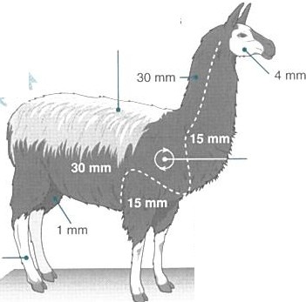

4mm

Thick fur insulates better because it lraps a thicker layer of air.

Heal generated by muscular activity and shivering.

Hair loss (moulting) in warmer months assists cooling.

### Te m peratu re reg ulati on mec hani sms in air

Behaviour or habitat choice

Heat generation from metabolic activity

Insulation (lat, fur, feathers) Changes in blood flow Large body size

Sweating and panting

Tolerance of fluctuation In body temperature

**'f..u.:? ·:-.-...#'i> ..,, .... m:.,., J7...**

, j, 1i.-W- .;;:.g0,

Fo r mos t mammals, the thickness of the fur or hair varies around the body (asindicateoabove).Thermoregulation is assisted by adopting body positions that expose or cover areas of thin fur (the figures above are for the llama-like guanaco).

Animals adapted to temperature extremes (hot or cold) can often tolerate large fluctuations in their body temperature before they become stressed. In camels, the body temperature may fluctuate up to 7°C (34"C to 41°C) over a 24 hour period.

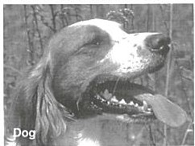 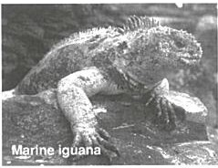 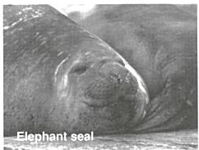 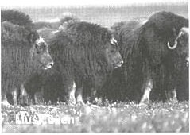

Panting to lose accumulated heat is importantin dogs, which have sweat glands only on the pads of their feet.

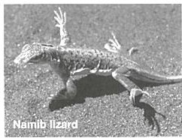

Behaviours to reduce heat uptake via conduction, e.g.standing on two

Circulation changes slow heat loss in water and speed heat gain when basking on landin marine iguanas.

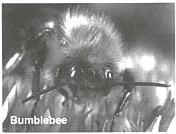

**j**

Bumblebees can heat up their fligh t musc les by shiver ing. T heir thick fuzz

**l",l"'lnc:onu:,c: thP hi:i,::11 thi0v nff"lf'hr1 i0**

Thick blubberand largebody size in seals and other marine mammals provide an effective insulation.

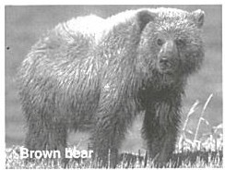

Thick hair, fur or wool traps air next to the skin.This insulating air layer

N><i,"""'

hA» I In!<'< :an<i ,:inw,;hP.:al M in .

Mammals andbirds In coldclimates, like the musk oxen above, cluster together to retain body heat.

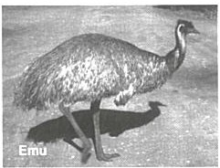

The plumage of birds acts similarly to fur or hair in mammals. The feathers



# 274

**Countercurrent Heat Exchange Systems**

## Countercurrent heat exchange systems occur in both aquatic and terrestrial animals as an adaptation to maintaining a stable core temperature. The diagram illustrates the general principle ofcountercurrentheatexchangers: heat is exchanged between incoming and outgoing blood. In the flippers and fins of whales



and dolphins, and the legs of aquatic birds, they minimise heat loss. In some terrestrial animals adapted to hot climates, the countercurrent exchange mechanism works in the opposite way to prevent the head from overheating: venous blood cools the arterial blood before it supplies the brain.

Bloodflow back to the body core

Bloodin the **vein** gains heat from the warmer artery as it flows back towards the body.

Capillary bed at the end of the limb

*2 4°C 18' C 12' C*

Vein < .............

* + - : **.....=--D '5** Hea t tr ans fe r **'5**

- **Artery**

#### *Cool environmental* temperature:

*1CJ'C or below*

On reaching the **capillary**

*3'1'C*

Blood flow from lhe body core

*31' C 2S'C t9'C*

Blood in the **artery** enters the limb at or near body core temperature. It cools as it flows towards the end of the limb, losing heat to the vein that flows alongside.

#### *13°C*

**bed,** the (now cooler) arterial bloodhas less heat to lose to the environmen.t

## (a) How does water differ from air in the way in which it transmits heat away from the body of an organism?

* 1. Identify two ways in which a "warm bodied" animal can maintain its internal temperature in water:
  2. How does a large body size assist in maintaining body temperature in both aquatic and terrestrial species?
  3. How do small terrestrial animals compensate for more rapid heat loss from a high surface area?

1. (a) How does thick hair or fur assist in thermoregulation in mammals? _ _ _ _ _ _ _ _ _ _ _ _ _ _ _ _ _ _ _
   1. Why is fur/hair thickness variable over different regions of a mammal's body? _ _ _ _ _ _ _ _ _ _ _ _ _ _ _
   2. How would you expect fur thickness to vary between related mammal species at high and low altitude?
   3. How do marine mammals compensate for lack of thick hair or fur? _ _ _ _ _ _ _ _ _ _ _ _ _ _ _ _ _ _ _
2. (a) Why do fast swimming fish use countercurrent exchange mechanisms in their swimming muscles?
   1. In some large sharks (e.g. white pointer and mako), countercurrent exchangers are used to maintain a higher temperature around the gut. What is the advantage of this adaptation?
3. (a) What is the role of group behaviour in temperature regulation in some animals? _

(bN)ame an animal, other than musk oxen, that uses this behaviou- r·